Mohan Kumar Ramalingaiah Neerakallu

Ramnee01@student.wintec.ac.nz

**WordPress Theme Development**

**Tutorial Report**

**Contents:**

Introduction ------------------------------- 2

Movie Theme ------------------------------- 2

Website sample pictures ------------------------------- 6

Basic coding sample screenshots ------------------------------- 8

Advantages and Disadvantages -------------------------------10

Conclusion -------------------------------11

References -------------------------------11

**Introduction:**

WordPress Themes are predeveloped templates of website layouts, that can be used to build our websites. These themes consist of home page and other pages including the forms for contact and register pages. So, this is very helpful for the developers or users in saving lot of time as we can skip the basic programming part of the web designing.

The advantages of using WordPress Themes is we can change the look and design of the website without having any prior knowledge in HTML or CSS (Król, 2019).

**Movie Theme:**

Developers have option to develop themes with different set of contents and also test the theme with a local server (Brad Williams, 2013).

I have developed a WordPress theme for Movies information and blogs about films. First, I have downloaded Laragon software and it comes with WordPress pre-installed. I have connected the WordPress with Laragon (so that I can check my website theme locally).

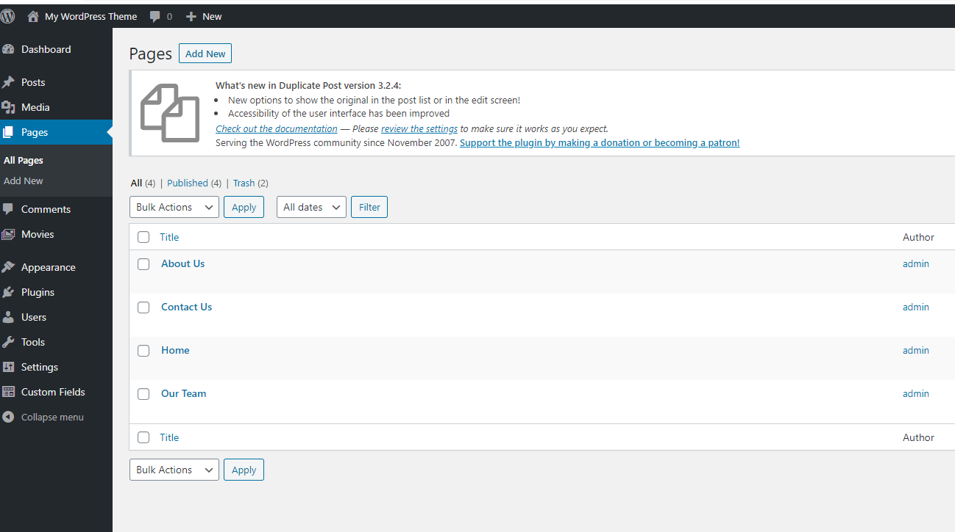

The above picture is the WordPress theme management page, where we can see the tabs – Posts, Media, Pages and Movies etc. In my pages tab we can see four pages – About Us, Contact Us, Home and Our Team pages.

We can click on any of those links and we can add content according to those pages. We can also add as many pages as we want. Here we can also manage those pages by selecting them and choosing options from dropdown box (in the above picture we can see “Bulk Actions”).

In the right side (Author section) we can see who has written those pages. Here, as I have created all those pages and the content inside is written by me (admin account), we can see “admin” in Author section.

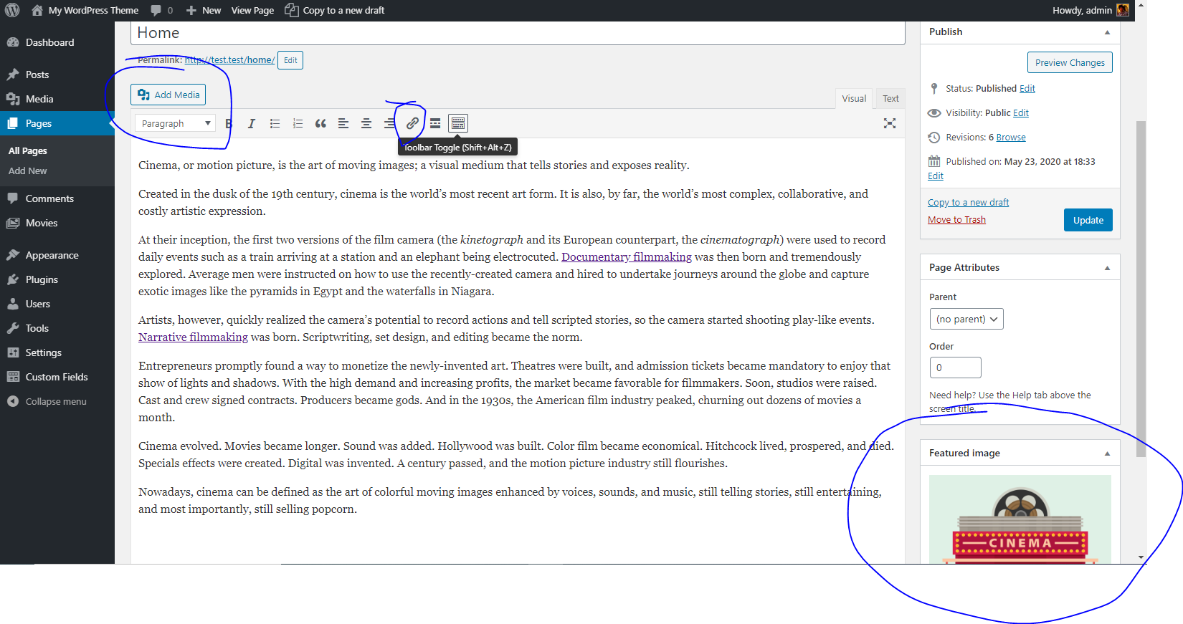

The above picture is the Home page content of my website. Here, we can add the information about the website. We can include links and media if we want. I have inserted a feature image of my website. We can do this with the help of “feature image” section at the bottom right corner.

In the same way I have added content to all the pages of the website.

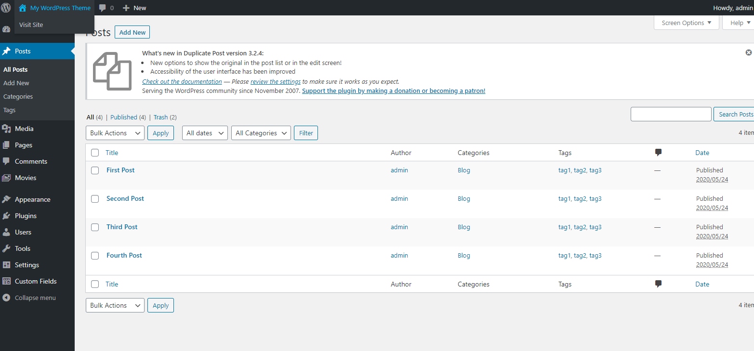

The above picture is about the blog posts on my website. This also works in a similar way of the pages of website, but here we can see archives of the blog posts and we can also arrange the order of blog posts. Blog posts are more like articles and it is easier for the business owner or website owner to write blogs with the help of WordPress Themes.

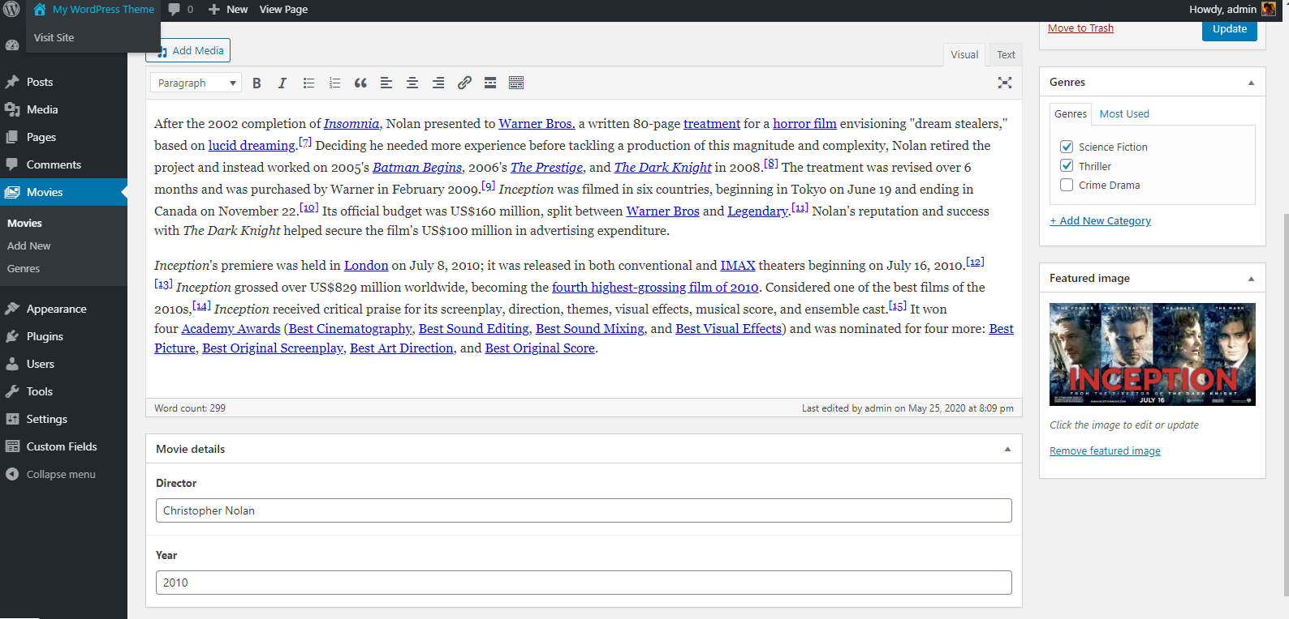

The above picture is an example of how we can easily add products to the website. In my WordPress theme I have created a tab called “Movies” so that I can add information about a movie individually without related to any of my pages. This feature is very helpful for adding products to an e-commerce site, if they do not want to include in the existing page and make it as special offer.

In the above picture I have used the tab at bottom called “Movie details”. I can fill those forms and those forms can be used to as many products (in my case it is a movie) as we want. Similar to blog posts and page content, here also we can attach any media. I have just attached a picture of a film.

I have created a tab called “Genres” at the right side and we can add as many categories as we want and select the categories before publishing the content. This helps to sort the number of products/films in a category. The below picture shows the number of films in each category.

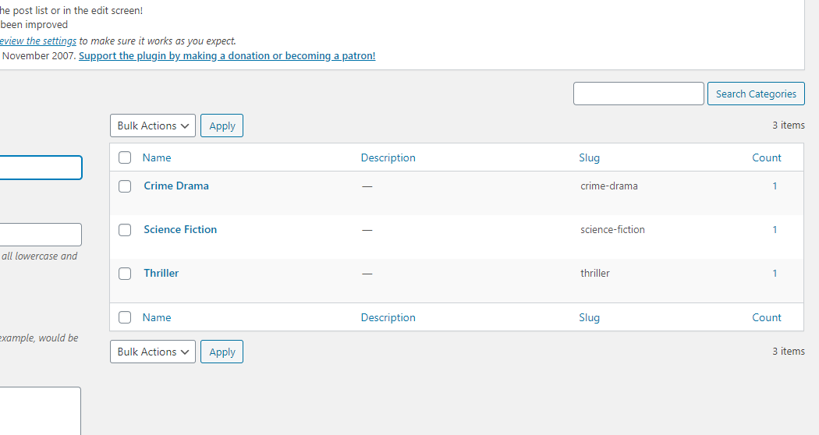

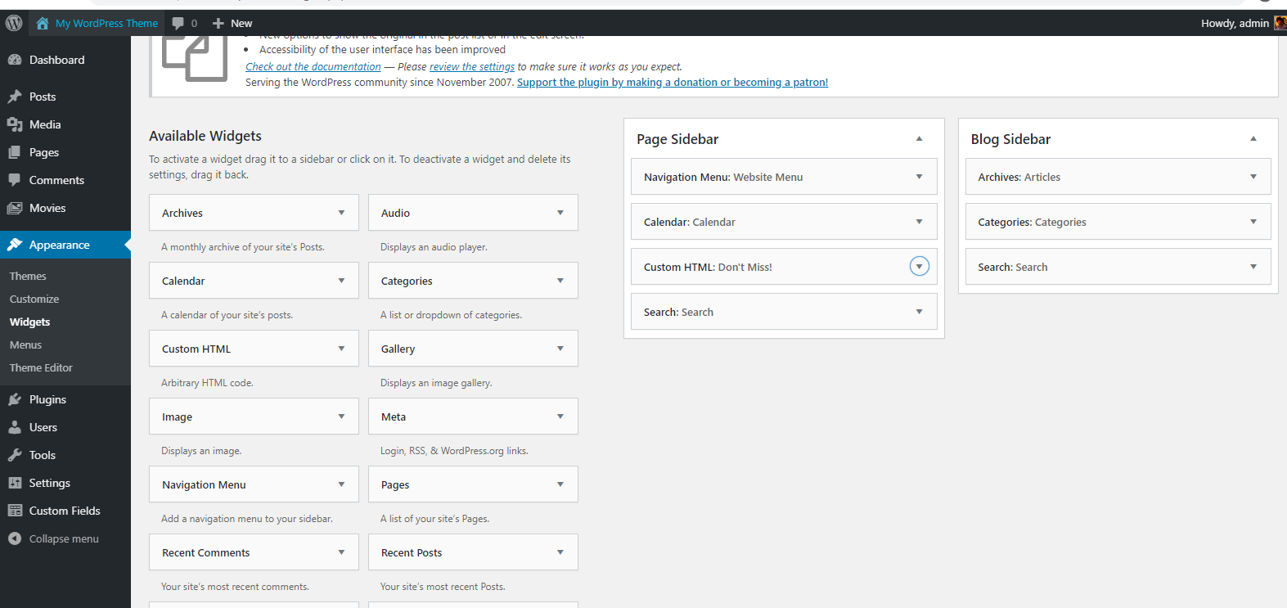

In the above picture we can see the widgets that I have added to my website. I have used Navigation Menu, Calendar, HTML(we can write basic html code here and the output will be displayed on the website below calendar), Search widgets.

In the Blog sidebar I have used Articles, Categories and Search Widgets.

**Website sample pictures:**

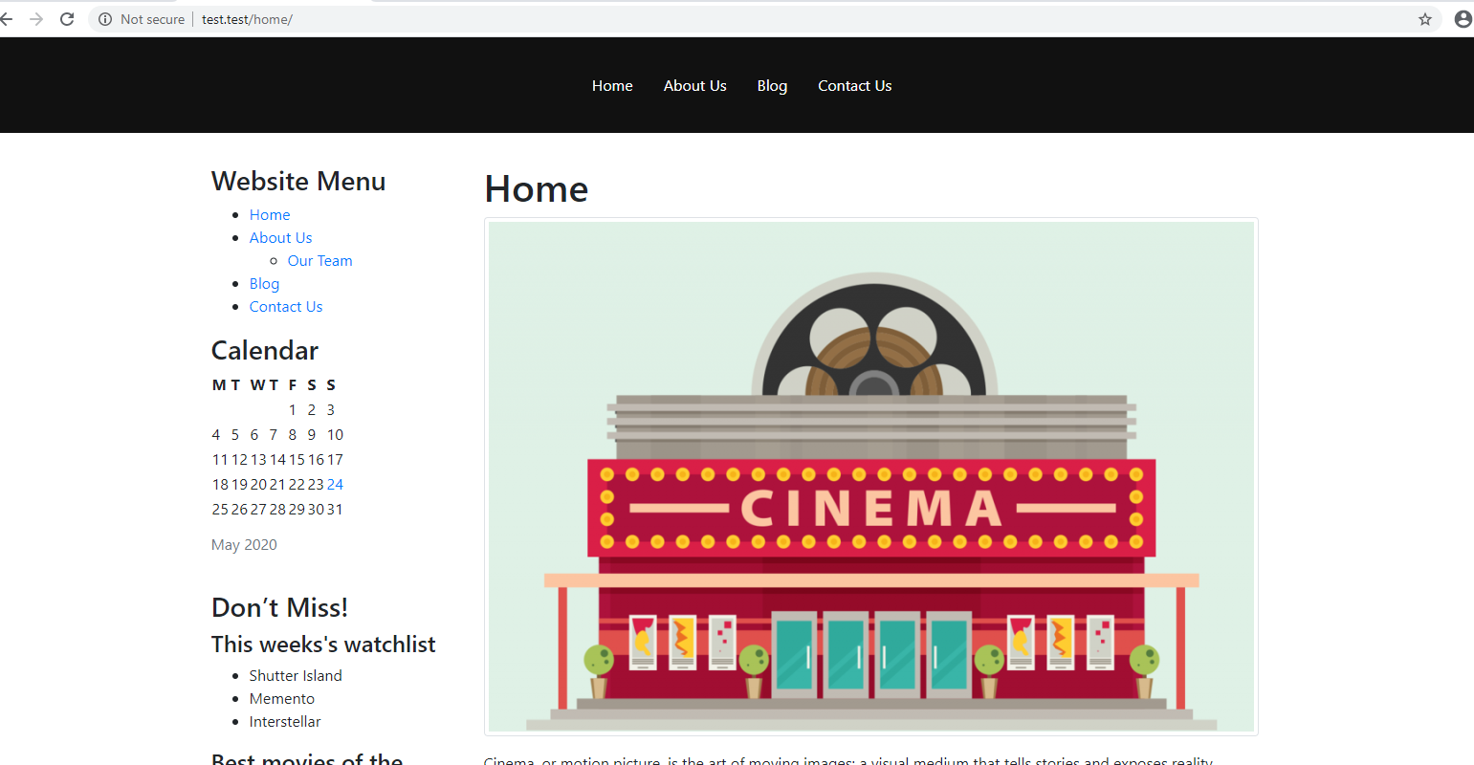

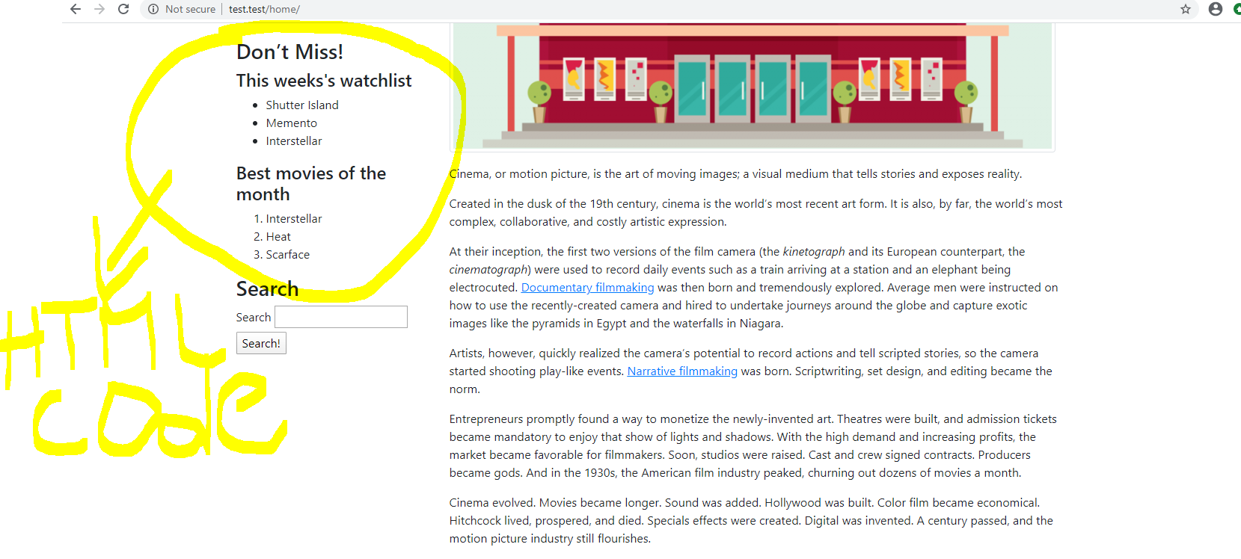

Code for the above html widget is attached in below screenshot.

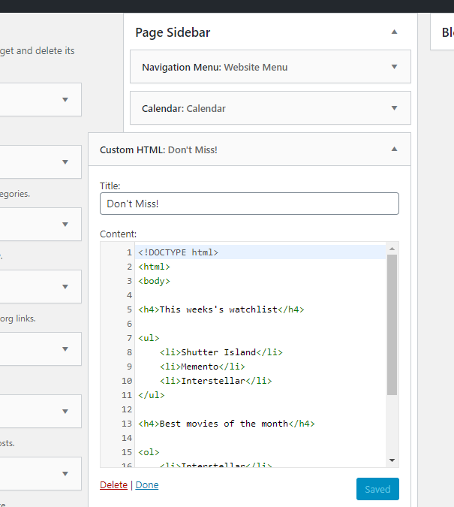

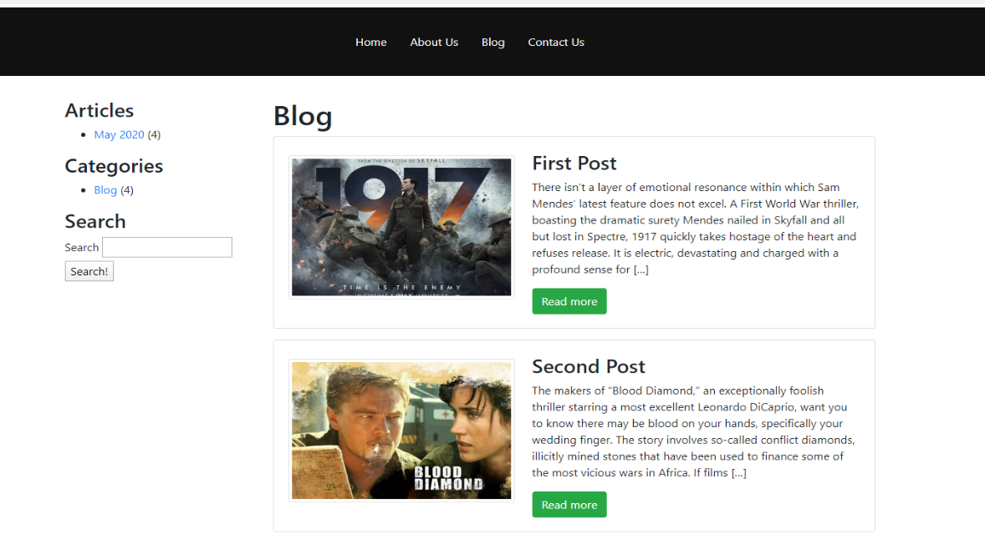

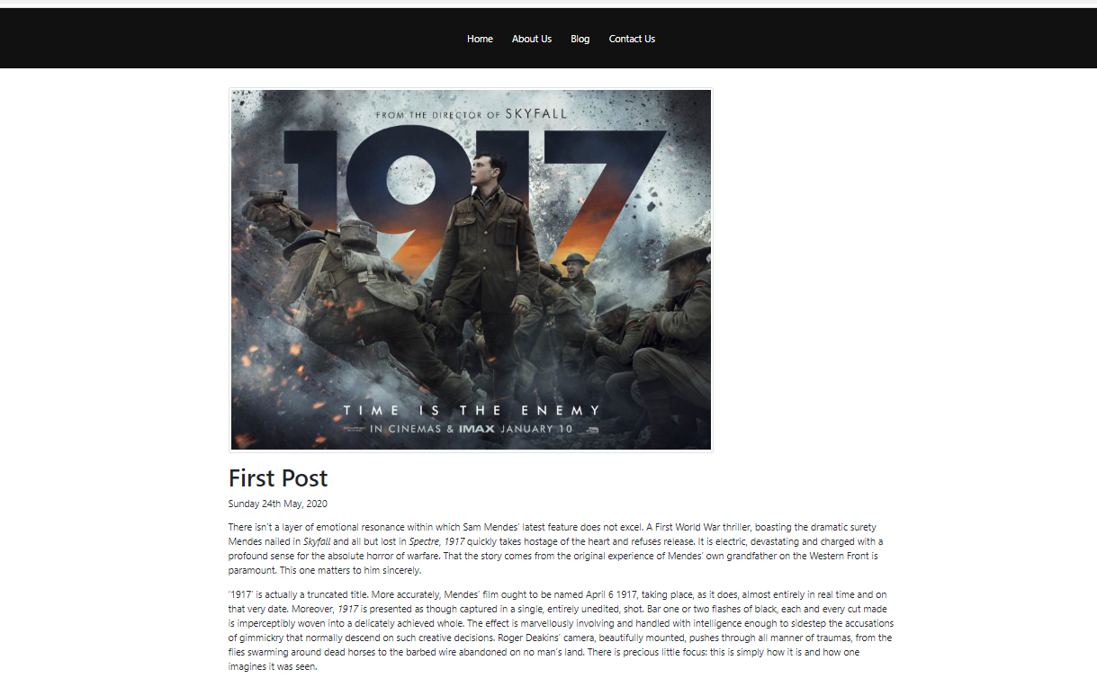

The above picture is one of the blog posts.

**Basic Coding Sample Screenshots:**

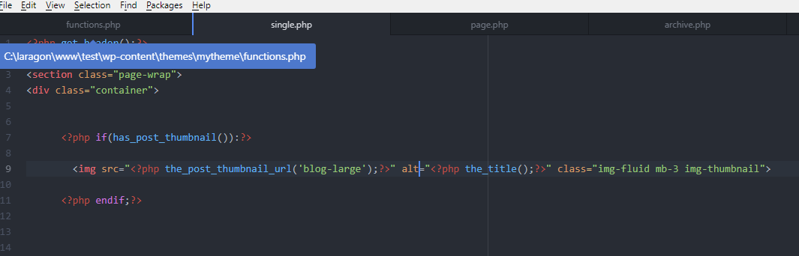

The above picture - To show the feature image we use <?php if(has_post_thumbnail()):?> to check and if there is an image it will be displayed.

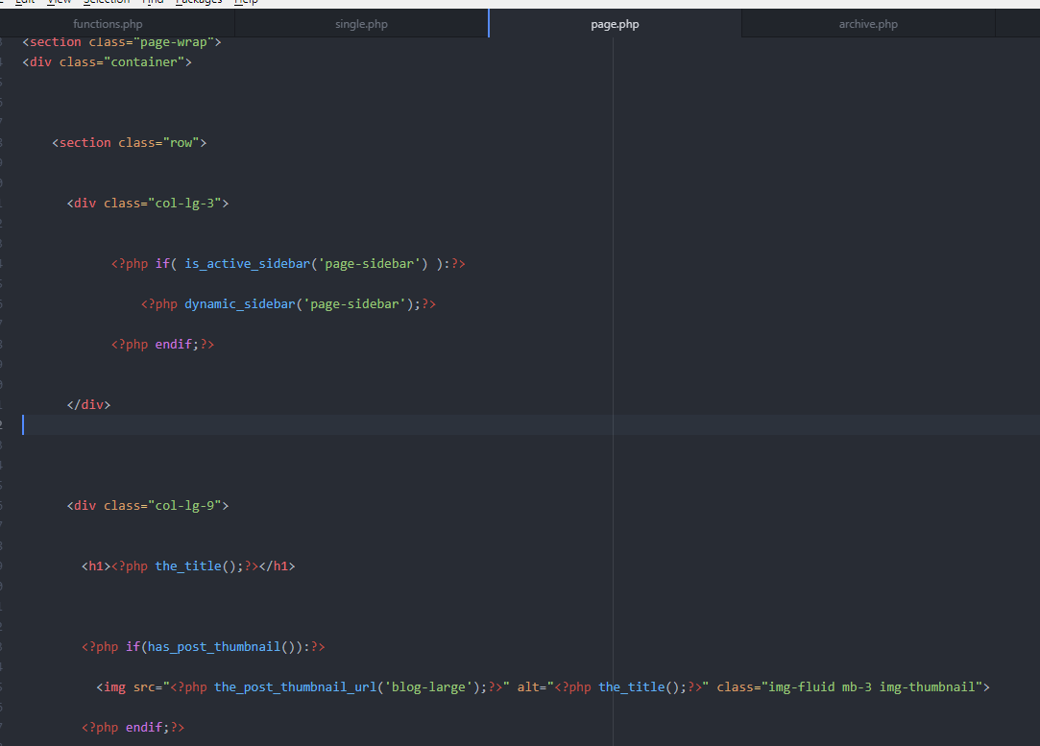

In above picture (DIgital, 2019) - The same loop used in single.php is also used here, so that we can put feature image in all pages like about us home etc. I used if condition to check if there are any sidebars in WordPress. If there are sidebars, they will be displayed in each page.

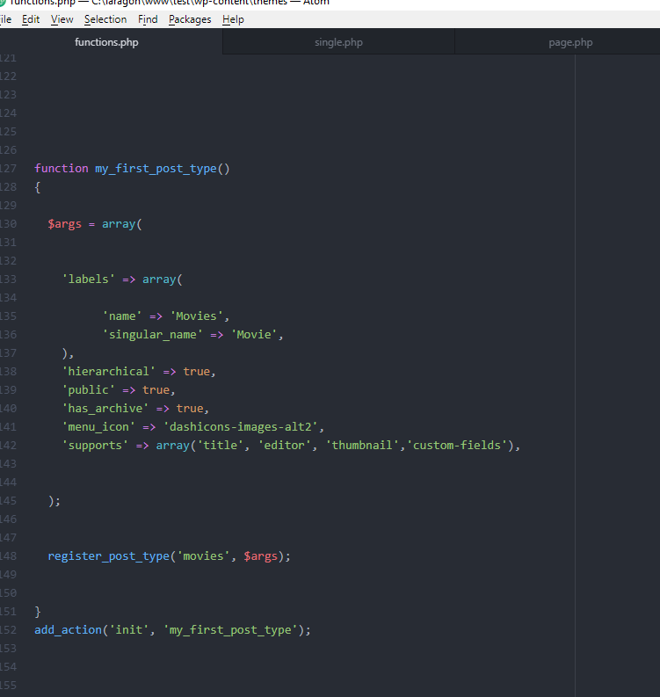

In the above picture - Movies tab is added on WordPress Theme. It is added by code in functions.php - function my_first_post_type() . So that website owner can directly add the products into the website using WordPress theme.

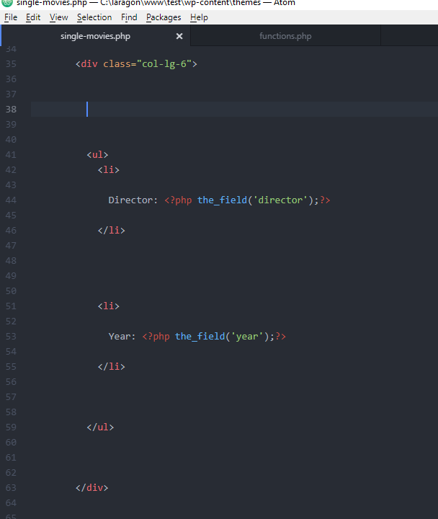

Above code: <php the_field (…);?> to display values entered in the form.

I have installed “Advanced custom fields” plugin:

With the help of this plugin we can add details of the product in a simple way by avoiding too much code. The value entered in these custom fields will be displayed on website.

**Advantages/Likes:**

* Reduced Upfront Investment
* Faster to Implement
* Mobile Friendly
* Industry Specific Themes

**Disadvantages/Dislikes:**

* No Technical Support
* Bugs
* Pirated and Hacked Templates
* Market Competition

**Conclusion (Do I recommend this Technology?):**

Considering the advantages and disadvantages of WordPress Themes, I believe the that prebuilt themes can be useful for specific websites like Cinema reviews, personal blogs, photography websites, free tutorial websites like cooking.

On the other hand, I think it is not very safe for websites which has payment sections or any News websites etc., as there is a chance of being hacked or facing bugs because of the improper design of the theme.

# References

Brad Williams, D. D. (2013). *Professional WordPress: Design and Development.* Indianapolis: John Wiley & Sons, Inc.

DIgital, M. (2019, september 21). *Youtube*. Retrieved from Mr Digital: https://www.youtube.com/watch?v=n3EcEYFgyrQ&list=PLgFB6lmeXFOpHnNmQ4fdIYA5X_9XhjJ9d&index=2&t=13s

Król, K. (2019). *WordPress 5 Complete: Build beautiful and feature-rich websites from scratch.* Birmingham: Packt Publishing Ltd.